Balloon pop!

Air is pumped out of the jar and the balloon gets bigger.
The drawing pins will pop the balloon.
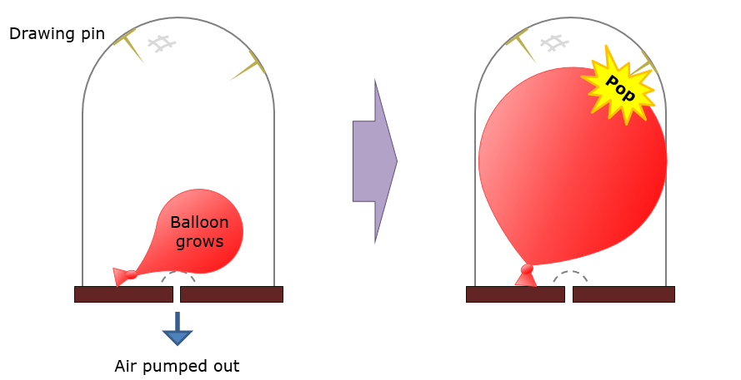
Predict
What do you think you will hear when the balloon pops?

Explain
Explain why you think you will hear this?

Now watch (and listen) to the demonstration

Observe
Describe what you hear when the balloon pops.

Explain
Were your prediction and explanation correct?
If not, can you explain what you observed?

Physics > Big idea PSL: Sound, light and waves > Topic PSL1: Sound and light > Key concept PSL1.1: Production and transmission of sound
Diagnostic question
Balloon pop!

Overview
Learning focus: | Sound needs a medium to travel through. It radiates out from a source in straight lines in all directions and when it strikes an object or new material it is transmitted, reflected, scattered or absorbed – or a combination of these.
Observable learning outcome: | Explain why sound will not travel through empty space (vacuum).
Question type: | Predict, explain, observe, explain - demonstration
Key words: | Particles, vibrations, vacuum

What does the research say?
Caleon and Subramanian (2010) note that students may think that sound is slowed down by physical obstructions and a few students believe that sound can travel through empty space (vacuum). Most students can state that sound does not travel in a vacuum, but the majority cannot explain way using scientific ideas.
In his study of twenty-eight 11-14 year olds Whittaker (2012) found that fewer than 30% used the idea of vibrations to correctly describe how sound travels through air. Half the students believed a gap around the door was necessary for sound to enter a room from the outside, which indicates a view of sound as a material substance. Only 20% were able to explain how sound vibrations can pass through the wall.
This question tests students understanding of why sound does not travel through a vacuum and helps to identify some enduring misunderstandings about how sound travels through air.
Ways to use this question
Students should complete this activity in pairs or small groups, and the focus should be on the discussions. It is through the discussions that students can check their understanding and rehearse their explanations.
To begin, each group should discuss the activity and use their scientific understanding, firstly to predict what they think will happen, and then to explain why they think they are going to be right. If students in any group cannot agree, you may be able to direct them with some careful questioning.
Students now watch the demonstration.
After the demonstration each group should be given the opportunity to change, or improve their explanation. A good way to review your students’ thinking might be through a structured class discussion. You could ask several groups for their explanations and put these on the whiteboard. Then ask other groups to suggest which explanation is the most accurate and the most clearly expressed, and through careful questioning work up a clear ‘class explanation’.
A useful follow up is for individual students to then write down explanations in their own words – without reference to the class explanation on the board (i.e. cover it up).
Differentiation
The quality of the discussions can be improved with a careful selection of groups; or by allocating specific roles to students in the each group. For example, you may choose to select a student with strong prior knowledge as a scribe, and forbid them from contributing any of their own answers. They may question the others and only write down what they have been told. This strategy encourages contributions from more members of each group.
Equipment
For the class:
- Vacuum pump and bell jar
- Partially inflated balloon
- Fully inflated balloon
- Drawing pins
- Piece of wire gauze
Technician notes
Put a partially inflated balloon into bell jar which has had a few drawing pins fixed to the inside with tape or blu-tack.
As air is removed the balloon expands and eventually bursts on the pins, but no sound is heard.
A small piece of wire gauze over the air outlet to prevent the swelling balloon from forming a seal over it.
Bursting the second balloon in the open air proves that a ‘trick’ balloon has not been used – and provides a clear contrast to the pop of the first one.
Expected answers
The balloon inside the bell jar can barely be heard when it pops because there are almost no air particles in the bell jar. Sound travels when there are particles that can be made to vibrate, and which can pass that vibration along.
There is a small amount of sound because the balloon is in physical contact with the solid glass jar.
When the balloon in the open air pops it is very loud.
How to respond - what next?
Some students may suggest that the jar is a barrier that stops the sound from escaping.
Other students may think that sound is transmitted by the ‘surfer model’ with a ‘lump of sound’ being pushed through the air by a wave of air particles. They might predict the correct answer and describe the air particles vibrating, but they may also describe lack of particles to push the sound forwards.
Those that think of sound as a material substance that moves from particle to particle are likely to make the wrong prediction.
If students use the idea of a barrier to explain their observations it may be helpful to place a sound source (for example a mobile phone) inside the bell jar when it is filled with air and can be heard. If students complain that this is because it is in contact with the solid jar, then this will support a discussion about how sound is transmitted by vibrating particles.
If students have misunderstandings about why sound does not travel through a vacuum, it can be helpful to demonstrate what is happening with a student model. A line of students, spaced well out, represent air particles. If the student at one end is made to vibrate (for example by an imaginary loudspeaker), the vibration is passed on from student to student without the students moving across the room. Removing students from the line will make it more and more difficult for the sound to travel.
The following BEST ‘response activities’ could be used in follow-up to this diagnostic question:
- Response activity: It’s quiet in space
- Response activity: Sound model
Acknowledgments
Developed by Peter Fairhurst (UYSEG), from an idea in the handout ‘What a good idea!’ from the Northern Physics Teachers Conference 1999 and produced by Norbert de Mello (Institute of Physics Teachers’ Network).
Images: UYSEG
References
Caleon, I. and Subramanian, R. (2010). Development and application of a three-tier diagnostic test to assess secondary students' understanding of waves. International Journal of Science Education, 32(7), 939-961.
Whittaker, A. (2012). Pupils think sound has substance - well, sort of ... School Science Review, 94(346), 3.

